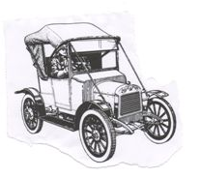
21st Irish Classic & Vintage Motor Show
Sunday 8th July 2012 in Terenure College, Dublin

Organised by the Irish Jaguar & Daimler Club
In aid of
The Children’s Sunshine Home & The National Maternity Hospital
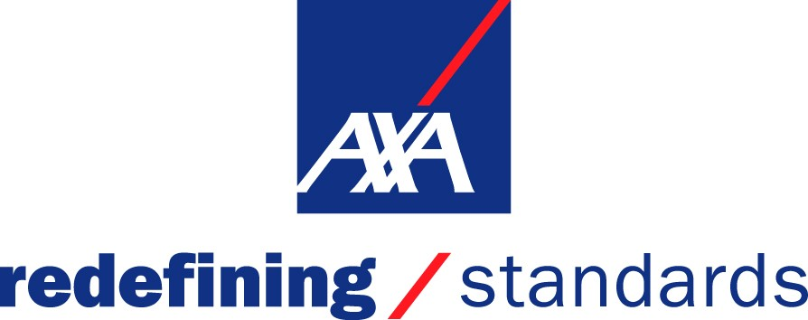
Sponsored by

You are invited to enter the 20th Irish Classic and Vintage Motor Show sponsored by AXA Insurance on Sunday 8th July 2012 in Terenure College, Dublin. The Grounds will be open from 8am, and in the interests of Public Safety we cannot have Cars moving around while large numbers of the public are present. Therefore we ask that all Vehicles be in place before 12.30pm . Late arrivals will park in a special area of the Public Car Park. In the interests of Public Safety, and out of courtesy to the paying Public we would ask entrants to remain on the field till 4pm. We realise that Entrants may need to leave earlier in an emergency, but we would request you try stay till 4pm.

VEHICLES ELIGIBLE: Veteran, Vintage and Classic Cars also Motorbikes, Commercial and Military Vehicles, Kit and Custom Cars, Sports and Super Cars, One Marque Clubs.

ENTRY FEE: € 20.00 per car and occupants.
Note that Commemorative Plate can only be guaranteed to for those who Pre-Registered by the 20th of June.

PRE-REGISTERING: Allows you to avail of a reduced price entry Fee, guarantees you a space in the field and a commemorative plate.

Entry Form
Please Complete using Block Capitals and full postal address.

Name: _____________________________________ Vehicle / Motor Bike Details

Address: ___________________________________ Make: _______________________
____________________________
____________________________ Model: ______________________

Telephone: ________________________________ Registration: _________________

E Mail: ______________________________________________ Year: _______________________

Which Club Stand do you intend parking on?

_____________________________________________________________________________

Entry Fee € 20.00, Cheque made payable to Irish Classic & Vintage Motor Show Account

This event is fully covered by Public Liability Insurance, however valid Insurance cover must be held by all Entrants for their Vehicles, as the Organisers or the Venue Owners will not be held responsible for any vehicle damage. The organisers reserve the right to refuse admission.

Signature _______________________ Date _________________

Please complete this Entry Form and bring it with you on the day.

Extra Forms can be found on our website www.irishjagclub.ie

